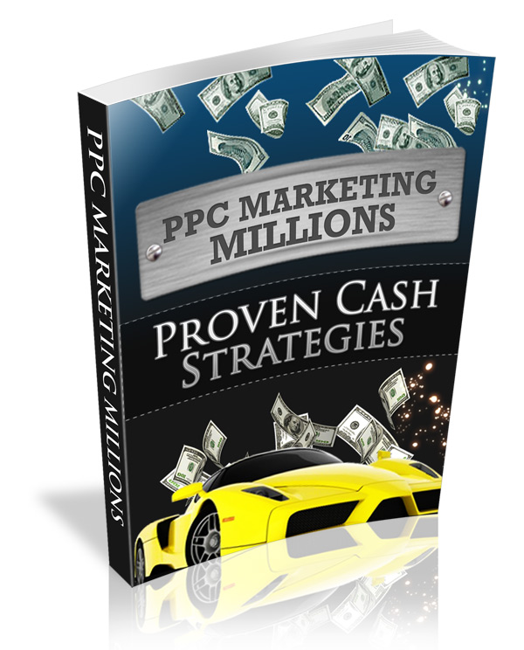
Your Domain Here

Table of Contents

Google Search Network Overview 6
Increasing Your Quality Score 11
Keyword Research Simplified 16
Creating Targeted Ad Groups 28
Setting Ad Budgets 40
Click Fraud 49
Writing Your Ads 51
Creating Winning Landing Pages 61
Split Testing Your Campaigns 74
Tracking Cost of Sales 79
Conclusion 81

Introduction To PPC Marketing Millions

PPC, which stands for Pay Per Click marketing has been in existence for many years now, with one of the more popular PPC marketplaces being Google's advertising program, Adwords.

If you aren't familiar with Google Adwords, it's very easy to understand and if you use the Google search engine for personal searches, you are already familiar with the marketplace layout.

Visit http://www.Google.com/and enter in a keyword string (any keywords under the sun, for example: Coffee Beans)

Adwords ads are the results that appear under the "Sponsored Listings" on the right hand side of the search results window, as well as the ones that are highlighted above the search results.

Take a look at the image below to see the ad blocks highlighted in red. This is where your advertisements could appear once they are live via the Adwords network.

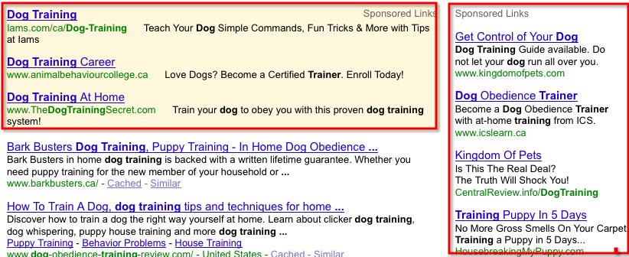

These are advertisements that PPC marketers using the Adwords system have created. They appear in block format and feature an ad title, two lines of ad copy, and a link that directs readers to their landing page.

Advertisers can create as many advertising blocks (and campaigns) as they wish and by bidding on keywords, their advertisements will appear within different positions.

So, how can an average joe marketer join the ranks of successful PPC gurus who have utilized the popularity of PPC search engines and marketplaces to jump start websites, establish an online presence, build a brand, grow a list and maximize their income potential?
It's all included within the PPC Marketing Millions guide, and if you have yet to set up your Adwords account, download the free set up guide available at:
http://www.YOURDOMAIN.com/PPC-Setup.pdf
The guide will show you exactly how to create your account quickly and easily.
Once that’s done, you’re ready to jump right into this guide, with our first chapter being focused on the Google Search Network, a powerful tool that will send unlimited traffic to your website in a matter of a few minutes.
Let’s begin!

Google Search Network Overview

Showcasing your advertisements within the Google Network can significantly increase your marketing exposure to customers, especially when you consider the fact that your ads will be eligible to show up on thousands of search and content sites and products, in addition to Google search results pages.

But what, exactly, is the Google Network?

It is made up of two areas – the Google Search Network and the Google Content Network. As an advertiser, you may select whether your ads will be visible on either or both of these networks.

The Google Search Network continues to be the industry leader, as evidenced by the fact that 76.7 billion searches were performed on Google in July 2009, which was an increase of 58 percent compared to the same month in the previous year.

What does this mean for your business?

It means you have an incredible opportunity before you!

Google Search

The majority of your traffic that will convert into sales should come from Google Search.

This refers to the ads that appear on the results pages when your potential customers are using the search engine, including Google search pages, properties that display search results pages such as Google Product Search and Earthlink.

The easiest way to think of this is when you sit down at Google.com, type a phrase in the search box, and then receive the results.

If you would like to tap into the mind of your target customers, think in these terms. The people who will find your ads through Google Search are actively seeking a solution to a problem.

That is why they have turned to a search engine – to find an answer to that particular problem. You have a greater chance of getting their business if you provide an answer to the solution they seek.

Google Global Search
The vast Google Global Search has the power to supply your business with an amazing reach, since it provides web sites and portals with access to 3 billion web pages and the world's most sophisticated search technology.

Revenue opportunities through Google partner sites are made available with sponsored links from Google's worldwide network of advertisers. These Google partner websites include many of the largest web sites in the world such as AOL, Ask, Earthlink, Google Maps, Google Product Search, and Google Groups.

Your ad can appear within dozens of external networks including Earthlink, Ask Jeeves, America Online and even Compuserve.

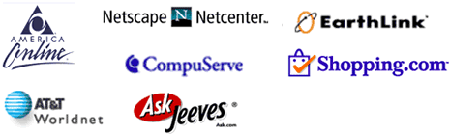

Your ads may appear above or to the side of the search results, on the results page as a user finds their way through a web site's directory, or on other relevant search pages.

Google Content Network

By choosing the Google Content Network, your adds will be display on websites instead of the alongside Google search engine results.

Think of the Google Content Network as an enormous group of web sites with the common bond of hosting AdSense as a way for the sites to bring in revenue.

This can be good or bad. It can be good because there are some quality sites out there, which will increase your exposure.

It can be bad as there are websites created with the sole purpose of encouraging visitors to click on your ads so the web site owner can make money (essentially, costing you money for invalid clicks).

Google actively monitors these situations, with an eye out for click fraud detection, and bans sites when deception is suspected.

The Google Content Network includes news pages, topic-specific websites, blogs, and other sites where visitors are actively engaged with content, as opposed to merely conducting searches. Your ads might appear if a web site’s content and URL correspond with the keywords in the campaign.

Content Network partners include About.com, Lycos.com, NYTimes.com, InfoSpace.com, ReedBusiness.com, HowStuffWorks.com, Business.com, FoodNetwork.com and HGTV.com. Users of Gmail may also see your ads within their email accounts.

The people who find your ads on the content network are more likely to be readers, as opposed to the users of Google Search being more likely to be searchers.

While searchers are actively looking for the solution to a problem, readers are often more leisurely about the interpretation and understanding of the actual content. This means that the searcher is more likely to click, while the reader is more likely to continue reading.

Increasing Your Quality Score

A Quality Score is assigned to advertiser accounts by Google AdWords, based on your Click Through Rate and several other factors.

What does the term “Click Through Rate” (or “CTR”) mean? This is a term you will see often as you build your business.

This is a percentage of the number of people who see your ad and actually click. If, for example, 100 people searched for your keyword phrase and then 20 people clicked, your CTR would be 20%.

Quality Scores were established in an effort to make sure Google provides its users with relevant ads. In other words, Google wants its users to see ads that have something to do with whatever the user just typed in the search engine, not some random topic.

Paying attention to your quality score will help to make sure that your ads will be seen by your target audience.
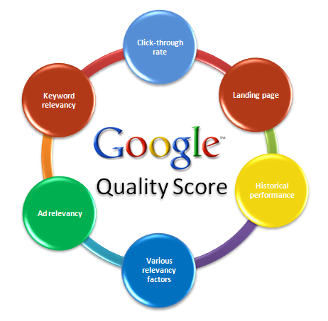

Your quality score can be influenced by factors such as your:

Click Through Rate: If your keywords’ CTR is high, Google views the keywords to be relevant and they receive a higher Quality Score, higher SERP position, and a lower minimum bid.

Account Structure: Google looks for logically structured accounts with relevant keywords. Small, tightly focused keyword groups will improve your Quality Score.

Keywords: It goes without saying that your keywords will be one of the most influential factors in whether Google determines your Quality Score to be “Poor,” “OK,” or “Great.”

Ad Text: The relevance of ad text is the largest factor when Google determines Quality Score. Your best approach is to organize your keywords into highly focused, relevant, targeted ad text.

Landing Page: Google’s spiders crawl landing pages on the web, and if they are unable to find relevant keywords that also appear in your ad group and ad text, your landing page is seen as being less relevant and will receive a lower Quality Score.

Minimum Bids: Your Quality Score measurements will be determined by keyword minimum bids. Google calculates keyword relevance related to the ad group, rewarding higher scores o sites that contribute to a positive user experience. Lower minimum bids are granted to keywords with higher Quality Score.

Ad Performance History: The performance history of your ads will be part of the Quality Score for site-targeted and search network ads.

The Unknowns: In addition to the factors that we just discussed, Google is known for keeping other factors quiet.

The list that we just covered looks pretty overwhelming, so what is the bottom line? What can you do to get the best Quality Score possible? Let’s focus on the most important factor – relevancy.

If Google does not view your ads as being relevant, your ads will not show up in searches and will not be seen by Google’s users. Your keywords, ad groups and landing pages should all make use of relevant keywords and build upon each other.

This makes it vital for you to incorporate into your ad campaign only keywords that are associated with your product or service. Adding random keywords (or keywords totally unrelated to your products or services) will not help your campaign. In fact, it will work against you.

On the other hand, if your keywords are associated with whatever the customer will likely enter as she searches for your products or services, your Quality score will increase.

The more focused your Google AdWords campaign is, the better. Concentrate on relevant, high converting keywords and your campaign will be more successful terms of how often it is appears, number of clicks, and the cost-effectiveness of your ads.

Now, I hate to throw a monkey wrench into all of this information that we have been discussing, but here is a little twist.

Although you will be creating a campaign that highlights keywords that are actually relevant to your products or services, they will not guarantee you with a high click through rate.

Why not?

Some keywords just out-perform others. They may attract more attention from computer users who are looking for specific data.

Usually, it is just a matter of modifying the lower- performing keywords to increase your CTR. It might take two or three tries before you notice improved results.

Keyword Research Simplified

As you begin to launch your online business, the Google Keyword Tool will be your best friend.

It really is a lot of fun to dig in and get your hands dirty with this tool because it allows you to see exactly what Google’s users are typing when they search for anything related to your products and services.

You can find it online at: https://AdWords.google.com/select/KeywordToolExternal.

Its purpose is to present you with the most popular descriptive words or phrases for a specific topic.

"Keywords related to term(s) entered - sorted by relevance"

When you type your niche or topic into the Google Keyword Tool, it will bring up relevant keywords and phrases to show you exactly what Google’s users have typed into the search engine when they are looking for products, service and web sites that have to do with the niche or topic you entered.

This list will appear under the heading, "Keywords related to term(s) entered - sorted by relevance.”

Begin by entering in a ‘seed’ keyword or phrase that describes the intended market that you are interested in advertising to.
In my example below, I entered in the keyword ‘credit’.

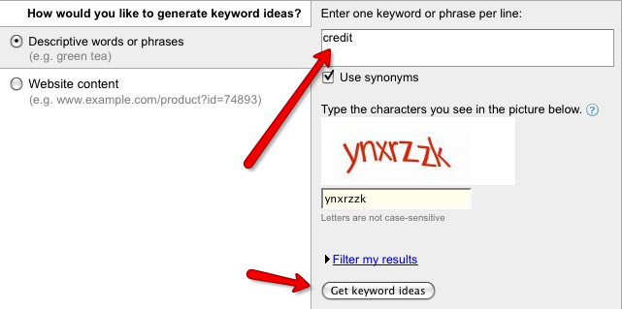

Hundreds of keyword possibilities appear, in their order of relevance, in the “Keywords” column on the far left side of the screen.

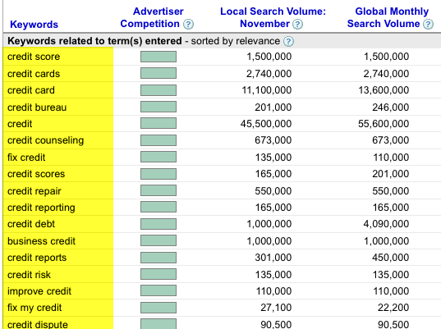

For example, when the word “credit” is typed into the Google Keyword Tool, some of the results include: credit score, credit cards, credit bureau, credit counselling, fix credit, credit repair, credit reporting, credit debt, business credit, credit risk, improve credit, fix my credit, credit dispute, no credit, credit rating, credit union, free credit report, credit card application.

Let’s take a look at the additional headlines -- Advertiser Competition, Local Search Volume, Global Monthly Search Volume, and Match Type.

Advertiser Competition
This shows you how many advertisers target these keywords. If a block appears in sold green, it indicates a high level of competition.

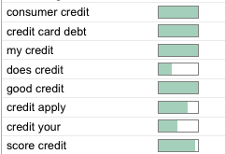

Local Search Volume [Last Available Month]
This column provides the approximate number of searches performed in your local area, matching the keyword result, for the previous month.

Global Monthly Search Volume
While the Local Search Volume looked at searches initiated in your area, this column shows the average number of searches matching each keyword result in all countries and languages.

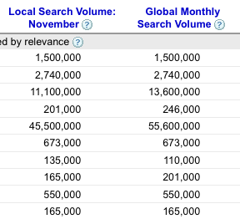

For all of the previously discussed columns, it is helpful to know that you can rearrange the order of the columns by clicking on the headlines..

For example, if you would like to see the results ranked in the order of Global Monthly Search Volume, just click on the headline, “Global Monthly Search Volume.”

Match Type
This column has a drop-down box to allow you to choose one of four keyword matching options – Broad Match, Phrase Match, Exact Match or Negative Match.

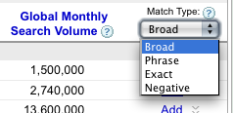

These options determine which Google searches can cause your ads to appear, helping you remain in charge of who will view your ads.

Broad Match, the default option, will let you rank for a wide variety of terms that may be related to your keyword. This includes synonyms and singular/plural forms of the keywords. For example, if a user entered “credit repair” and your keyword was “credit,” your ad would appear.

Phrase Match will allow your ad to appear if the search query includes a phrase that contains your keywords.

If you enter your keyword in quotation marks, such as "credit repair," your ad would be eligible to appear when a user searches on the phrase credit repair, with the words in that order.

It can also appear for searches that contain other terms as long as it includes the exact phrase you've specified.

Phrase match is more targeted than broad match, but more flexible than exact match. For example, if a user entered “bad credit repair,” and your keyword phrase was “credit repair,” your ad would be eligible to be triggered.

Exact Match allows your ads to appear if someone types that exact keyword phrase. By placing your keywords in brackets -- such as [credit repair] -- your ad would be eligible to occur when a user searches for the specific phrase 'credit repair,' with the words in this exact order, and without any other terms.

You probably will not obtain as many impressions, clicks, or conversions with exact match as you would expect with broad match, but the traffic generated is likely to be better targeted.

Negative Match will make certain that your ad does not appear for any search that includes that term.

If your keyword is “credit repair” and you add the negative keyword “-free,” your ad will not appear for any searches that contain the word “free.” The negative keywords feature is very helpful if your ad campaign containers many broad-matched keywords.

For more in-depth details on broad, exact, phrase and negative matches, visit: http://AdWords.google.com/support/aw/bin/answer.py?hl=en&answer=6100.

When you are you ready to add your keywords to your AdWords account, click on “Sign Up With These Keywords.” The system will also allow you to add your own keywords or variations of the keywords provided by the list.

Before you make up your mind regarding using specific keywords, you might want to use Google’s Traffic Estimator tool to find out how much traffic to anticipate from these keywords.

Download your keyword list in text format and enter the list in the Traffic Estimator’s text box. You will then be able to view the estimated traffic.

Google’s Traffic Estimator also provide you with an estimated ad position within the Sponsored Listings, and estimated Clicks Per Day based on the various keywords that you have entered.
The Traffic Estimator tool is available here:

https://AdWords.google.com/select/trafficestimatorsandbox

"Additional keywords to consider - sorted by relevance"

Beneath the “Keywords related to term(s) entered” list, Google will present you with additional keywords to consider, also sorted by relevance.

This list will appear under the heading, "Additional keywords to consider - sorted by relevance.”
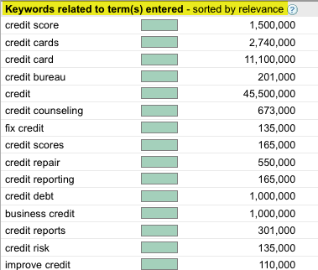

When we return to the previous example, having typed “credit” as our niche, some of the options reported here include: mastercard, small business, personal loans, loans, financing, debt consolidation, unsecured loan, cash advance, short term loan, debt management, online loan.

Depending on your niche, you might very well see that proverbial light bulb come on above your head as you scroll through the additional keywords to consider.

Quite often, Google suggests phrases that you might not have considered, that would be great options, and people are already looking for them online since they were relevant to show up.

Keyword research is a crucial part of your AdWords marketing. These skills will also benefit your other types of online businesses, including article marketing, blogging or natural SEO. It is wise to compile a list of relevant keywords for your niche.

Using these keywords effectively on your own web site will aid in your Search Engine Optimization efforts.

Your site will rank higher if Google recognizes your keywords used throughout the site’s content, titles of pages, and in web page descriptions. This will help send more traffic to your site. This can be a fantastic advantage for you, especially when you are up against web sites that do not understand or put these methods into practice.

Similar to using keywords on a web site to boost ranking and traffic, if you use your keywords within your ad group you will have better results.

By taking some time to play around with keyword research, you can take steps to receive maximum exposure for your ads. Set aside some time to tackle this research, and document your results in a simple Excel spreadsheet so you will have them as a reference tool.

You will soon gain some valuable insight as far as the popular, relevant keywords that computer users are entering when they search through Google.

Compile a list of these keywords and refer to it as you write your ads. Including these keywords in your ads will make certain that your ads will be prompted and appear when a user enters the keywords that you have targeted.

Google’s Keyword Tool is not the only option, by the way. There are other products and services to choose from, both free and paid.

It is a good idea to use more than one service, just to make sure you receive the most well-rounded, informative results as possible before you make decisions.

Additional Keyword Resources:

Add Goo Roo
http://free.adgooroo.com/

Good Keywords
http://www.goodkeywords.com/

Google Search Insights
http://google.com/insights/search/#

Hexa Track
http://www.hexatrack.com

Key Compete
http://www.keycompete.com

Keyword Discovery
http://keyworddiscovery.com/search.html

Keyword Spy
http://www.keywordspy.com

SEO Book Keyword Tool
http://tools.seobook.com/

Word Tracker
http://www.wordtracker.com/

Wordze
http://www.wordze.com/

Yahoo Search (formerly known as Overture)
http://advertising.yahoo.com/smallbusiness/ysm

Creating Targeted Ad Groups

Placement Targeting
Before you make a decision about a site where your ad will be featured, keep this in mind. This site must have highly focused pages and stay true to the niche topic in order for your ad to remain relevant.

Maintaining relevancy with your ad is critically important to sustaining high click through rates (CTR).

This is true of Google AdWords keyword ads and also on the content network. However, many advertisers have no idea how this works. Use this to your advantage and outshine the others.

What is placement targeting?

Rather than targeting your ad to appear anywhere on a certain site, you target the most drilled-down, focused pages from several sites, all highly relevant to your keyword phrase.

This allows you to receive approximately the same number of clicks as you would have, but for far less impressions.

This means that your CTR would soar and, since you are paying per 1,000 impressions, it keeps the price that you pay for each click incredibly low.

The beauty of placement targeting is that it allows you to decide on individual locations within the Content Network where you would prefer for your ads to be displayed.

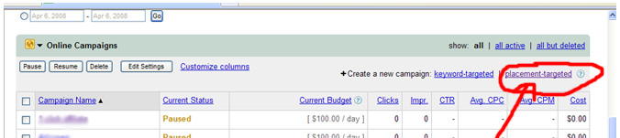

Google AdWords looks at your managed placements when looking for appropriate places for your ads to appear.

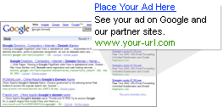

Placement might occur on an entire website, or a subset of a site. For example, you might be targeting executives who need your product or service, so you would prefer for your ad to appear only on the business pages of a particular newspaper, rather than on every page of the newspaper’s web site.

Computer users who are focused on that newspaper’s home and garden pages, for instance, might not care about what you are offering CEOs, so it would not be advantageous for you to spend your budget there.

In order to participate in placement targeting, a web site must be part of the Google Network.

If you are interested in placement on a particular web site, use this link to view a list maintained by Google: http://AdWords.google.com/support/aw/bin/answer.py?answer=6119&topic=82/

Use the AdWords Placement Tool to find placements for your ads as you create new campaigns or ad groups. For more information about using the Placement Tool, visit: http://adwords.google.com/support/aw/bin/answer.py?hl=en&answer=112274

Remember that you will be competing for space against other advertisers. You will pay higher prices for more visibility if you are focused on the most well-known, foremost web sites.

These top-tier web sites could easily eat right through your budget, so make sure your ad is flawless before placing on exclusive sites.

Targeting Ad Groups

Let’s create a targeted ad group.

Our first step is to go into our AdWords account and create a campaign to hold the targeted ad group.

A screen will appear to name the campaign and its first ad group.

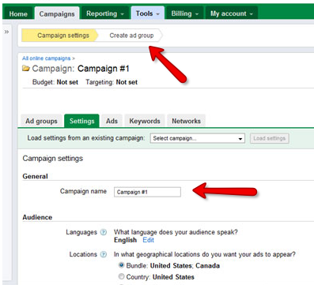

Click “continue” and then you will be able to choose the specific locations that will apply to your advertisement. Even when creating site targeted campaigns, you will be able to target the ad based on the language and location of the searcher.

NOTE: If you have a brick-and-mortar store or if you offer your product or service within a specific geographic location, you might think about targeting searchers in your specific area.

However, if your product may be downloaded or shipped to your customer, this would probably not be a consideration for you. Just keep this feature in mind as you begin new campaigns.

One suggestion, at this point, is to create multiple site targeted campaigns based on the geographical target audience, rather than any other criteria which may give the impression of being more logical.

If you have already run a split test (discussed in another chapter) and have your winning ad ready to go, this would be the ideal time to use it.

Split test ad winners ads are wonderful for this technique and fare very well since you will target the same searcher for the same search term.

This is also a great way to make compare the value of the ad currently being shown in your keyword campaign phrase vs. the ad we are now creating.

As you approach the New Site-targeted Campaign Setup screen, you will be able to obtain Google’s advice in choosing sites where your ad will reside. Option 1 allows you to browse categories, and option 2 lets you use keywords to find suitable matches.

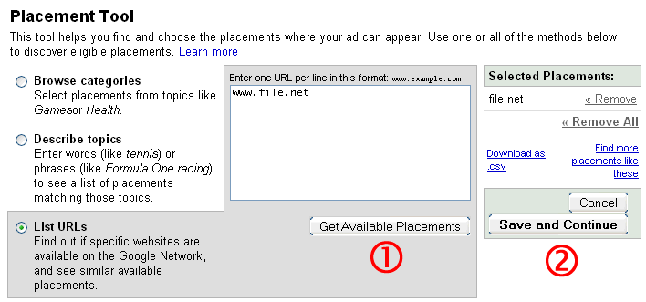

At this point, let’s assume that we know where we would like for the ads to appear, so we will click “List URL.”

Now, we will need to open another browser window for the next step. Go to Google and type your keyword phrase into the search box.

Once the results appear, click on the first result (in the natural search area, not the sponsored area).

Take a look at that site to determine if it is hosting Google ads. You will often find these ads with the words “Ads by Google” on top, in the following formats:

- Skyscraper – long, vertical rectangle with ads stacked on top of each other
- Block – usually a square situated within the body of the page (rather than being placed along the edge of the page)

Google ads are often quite obvious on the page, leaving you no doubt that they are, in fact, Google ads. The top center of the page and the left side of the page are two popular places.

The color of the ad and the amount of web site text surrounding it are also concerns.

The ad block should stand out from the rest of the web site, attracting the reader’s attention rather than blending in and becoming invisible. The more the ad block stands out from the main portion of the site, the higher your chance of a profitable click through rate.

If, when you type your keyword phrase into Google, you discover that the first natural search result does not have Google ads appearing on the web site, click to go back to the search results page and try clicking on the site directly under it.

Continue doing this until you have found the first natural search result with Google ads on the page.

Found it? Great! We need to grab that URL, so let’s highlight it in the browser box, right-click, and select “cut.” Paste it into your clipboard.

We are now ready to return to your original browser window, where we began creating the ad group, on the New Site-Targeted Campaign Setup screen.

On the left side of the page, tick the radio button that says, “List URLs.”

Remember that URL we cut and pasted into your clipboard a few moments ago? Paste it into the box on the right side of the page.

Now the system expects us to add an entire site, although the arrow indicates that we are unable to continue because no site has been chosen. For the time being, let’s click “Get Available Sites” to enter a temporary site.

A new screen will appear, asking you to select any or all of the recommended sites.

We want to select the first site listed, but we only want our ad to appear on one page within that site. Click to choose the site, and then choose to continue.

Daily Budget / Maximum CPM Amount

The next screen will ask for both a daily budget and a maximum CPM amount. Since these can be changed later, it is best to start out with both amounts low.

Upon saving this campaign, your ad is now available to appear on the entire site that you selected. Remember, we just chose that option temporarily so the system would let us continue through the process. The next few steps will remedy this situation.

Next, you will see the Campaign Management screen. Click on the name of the ad group you just created.

Click Edit Sites and CPMs.

Now, to change from the whole site previously selected to the single URL we want to use, while still in the Campaign Management screen, delete the URL that appears and replace it with the URL that we found a few minutes ago (the one that should still be in your clipboard). Make sure the URL does not begin with http:// and does not end with any of the following: .html, .htm, .php or .shtml.

These extensions would indicate a single page, which is not what we want.

Save your changes.

It is a good idea for each ad group to be made up of three or four individually targeted pages.

This procedure may sound like it takes many steps and a lot of time, but once you get the hang of it, it won’t take much time at all.

Once you’ve completed these steps, it is time to think about adjusting your maximum CPM amounts to make sure the ads show up. It may be necessary to jump from a few cents to a couple of dollars.

This can easily be taken care of by changing the Max CPM in the box, which is like changing the Max CPM for all of your URLs.

You may be thinking that it might seem risky to spent a couple of dollars for your ad to appear a few hundred times. After all, there is no guarantee that anyone will click, let alone buy.

Look at it this way:
If you pay $2.00 and the ad is shown 1,000 times, for a CTR of 10%, it will have cost you just two cents per click. It is not difficult at all to see results like this. Just be certain that your ads are appearing on pages that rank high in the natural search engines.

Once you have set up this first campaign, keep going.

Create another ad for this keyword phrase and go through the entire process once more. Just click “Create New Ad Group” in the Campaign Management menu go through this process while it is still fresh in your mind.

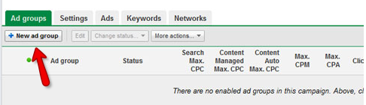

Seeing Results

Within 24-48 hours, you should begin to notice statistics indicating impressions and clicks for your new ad groups.

Watch out for the unbalanced combination of enormous impressions/low CTR in a new ad group. If this happens, pause the ad group and take a look at the sites where your ad appears.

The most common problem is inadvertently setting the ad group up for your ad to appear on all pages of a high-volume web site.

This is easily corrected, and then you may re-activate the ad group and continue as usual.

Setting Ad Budgets

Your AdWords account actually has two budgets -- a daily and a monthly budget.
The daily budget sets the maximum amount you wish to spend on your AdWords campaign on any given day.

The monthly budget represents the total amount you wish to spend for an entire month.

While separate, the two budgets do have a direct impact on each other. For example, if you set a monthly maximum but fail to set a daily limit, you risk running through your entire monthly budget in just a few days. So, as you can see, it is vital to have a firm understanding on both your daily and monthly limits.

Advertisers who are new to Google AdWords frequently set their ad budgets too low, usually because they are fearful of losing a big chunk of change.

If your budget is pretty low, then you probably either have not yet grasped the magnitude of what Google AdWords is capable of doing for your business or you are cautiously playing around with the numbers to see what works best before throwing more money into the budget.

One of the great things about Google AdWords is being able to stay in control of your budget. If you are on a tight budget and need to be sure, down to the penny, about how much you are spending on your ads in a given month, AdWords lets you stay in charge.

Cost Per Click

As an advertiser, AdWords will charge you each time someone clicks on your ad. You are not charged for the number of times your ad appears, which is referred to as “impressions.” Only the number of clicks.

Determining the Cost Per Click (CPC) is one of the best ways to stay on top of your budget. Here is an easily formula to determine your Cost Per Click:

Cost Per Click to reach break even point =
(Profit Per Sale in $ x Conversion Rate) / 100

For example, let’s say that you are selling a product or service which would give you a profit of $60 per unit sold.

Your conversion rate (the percentage of people who click on the ad and visit your website who actually make a purchase) is 1 person out of 100, or 1%. Both these figures would be put into the equation.

- Profit per sale = $60
- Conversion rate = 1%

The maximum CPC would be calculated as: ($60 x 1) / 100, which is equal to $0.60.

Therefore, you can afford to pay a maximum of $0.60 per click in order to break even. This means that, if you want to make a profit, your AdWords campaign should be set to pay a CPC amount lower than $0.60.

Let’s say you want to spend $50. Quite often, $50 will not get you too far. However, it depends on the Cost Per Click, so you can see how important it is to determine CPC.

Your CPC could be $0.20 or it could be $2.00.
Daily Budget
Now you will need to determine a daily budget that you feel comfortable with. For this example, let’s say that your CPC is $0.50. In that case, since you originally wanted to spend $50, you could easily afford 10 clicks a day for 10 days.

One smart way to launch a new campaign’s daily budget is to get started with between $15 and $25.

Watch carefully for the first few days to see how the campaigns are doing. At this point, you’ll want to ask yourself if you should tweak the ads or increase the daily budget.

When setting your daily budget, you might consider setting it at (or lower than) the average sale price or commission of whatever you are selling. The reason for this is many people will not buy the first time they click to visit your site.

While some people will bookmark your site, once they find it, there is always a chance that others might go through the process of typing their keyword into the search engine again, look for your AdWords at to appear in Sponsored Listings again, and then click.

So this means you could, potentially, pay for several clicks for the same person to make their way to your site enough times to finally make that purchase.

If you set your daily budget low, keep in mind that your ads will not show up as often as they would with a higher budget. This is because Google spreads them out to allow them to have the chance to appear throughout the day. However, you can change this feature to an accelerated setting within your account.

In addition, if you bid far too low, your ad might not show up at all. This is why it is important to pay close attention to your campaigns. If there is a problem, you can go in and adjust the settings, and then watch to see if it makes a difference.

By keeping your daily budget fairly low at first, you will be able to play around and find a groove for the ad itself and for your daily budget, without breaking the bank.

Maximum Bid

Your maximum bid is something else to take into consideration. A good place to start out would be $.40 to $.55, which gives you room to play around and also benefit your Quality Score while generating targeted traffic.

Google’s Traffic Estimator Tool will be very helpful once you reach this stage of the game. The tool can be found at: https://adwords.google.com/select/TrafficEstimatorSandbox

This tool provides an easy way to find out your position well in advance of ever setting your maximum bid. This tool uncovers your average costs per day and per click, based on keywords you have entered. It also shows where you hope to rank within those results.

Inside your campaign’s control center, you will see a Keyword/Minimum Bid table. This area lets you see how much it will cost in order to reach a specific position within Sponsored Listings.

It also shows how much you can anticipate paying for each click based on keywords within that campaign.

Pay attention to your Quality Score. As it increases, lower the maximum bid for your campaigns until you have reached a point where you are paying less per click while still receiving great results.

Your ad budget may require some modifications along the way, before you discover an amount that works for you.

However, if you face unexpected expenses as the month progresses, don’t freak out. It is possible for you to lower the budget without closing down your campaigns.

Whatever you do, if you are in a financial pinch, do not turn off the ads completely.

Instead, lower the bids a bit, set your day parting times to the highest converting times, and lower your budget to $10 to $20 per day.

This allows your campaigns to remain active, lets you continue to receive clicks, and maintains both your CTR and Quality Score.
There are several ways to work with AdWords in order to make your budget even more economical.

Get the Highest Quality Traffic Available
Utilize the highest quality traffic possible in order to obtain the greatest possible conversion rate if the search volume for your product or service looks like it is going to outstrip your daily budget.

From the “Edit Campaign Settings” page, choose to have your ads show on Google Search, Search Partners and the Content Network.

Deselect Search Partners and the Content Network. It is quite possible that Google Search, by itself, will be able to send enough traffic to eat right through your daily budget. Also, it is more likely to be the highest quality source of traffic.

By the end of the day, you might see that some of your budget remains. If that is the case, re-enable Search Partners.

Take Advantage of Ad Scheduling

Google’s Ad Scheduling lets you plan when your ads will be shown, and it will reduce the bids at certain times of the day. This feature is found on the “Edit Campaign Settings” page.

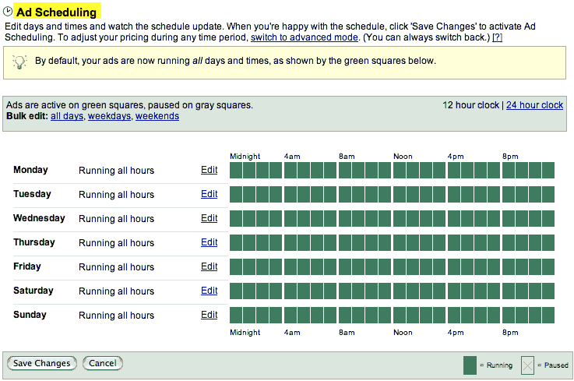

This is especially attractive if your product or service is geared toward the business-to-business sector.

You might want to prevent your ads from running on the weekend, preferring for them to appear during the workweek when decision-makers would be more likely to see the ads.

Mind Your Negative Matches
Your broad match keywords can be very valuable to provide a high volume of traffic, so they should not be paused unless you absolutely cannot avoid it.

The only problem is, your broad match keywords might be triggered for unrelated searches. Occasionally, Google users might click on your ads out of confusion, which costs you money, might cause your CTR to plummet, and could lower your Quality Score and increase your CPCs.

Make sure to painstakingly investigate your keywords and so that your campaigns or ad groups are made up of the necessary negatives to guarantee your ads are only shown to actual prospects.

Evaluate Your Analytics
Take advantage of using Google Analytics to find out the performance of your PPC campaigns.

This is a good way to distinguish which of your organic keywords are responsible for the most conversions. This information can help your PPC campaigns achieve higher conversion rates.

Do Not Strive For #1
Shoot for your ads to appear in a position other than #1.

In fact, strive for anywhere in the #3 to #5 range.

This way, you will have a much lower CPC, a somewhat lower CTR without falling short in conversion rates. The #1 position, on the other hand, tends to be the most expensive and its high CTR could possibly devour your daily budget quickly.

Click Fraud

Any discussion of Google AdWords budgets deserves to mention the possibility of click fraud. It is a concern on the minds of all Google AdWords advertisers, whether experienced or brand new.

What is click fraud?

It occurs when an individual, an automated script, or a computer program click on a PPC ad for the sole purpose of generating revenue. Convictions have been upheld in situations where it was determined that the clicks were performed maliciously with the goal of depleting a competitor's ad budget.

Click fraud is actually considered a felony in some jurisdictions in the United States and in the United Kingdom.

According to a study conducted in the third quarter of 2009:
- Botnets accounted for 42.6 percent of all click fraud in Q3 2009. This was a significant rise – more than doubling in the past two years and up from the 27.5 percent reported for the same quarter last year.
- The overall industry average click fraud rate was 14.1 percent. That’s up from 12.7 percent for Q2 2009 and down from the 16.0 percent rate reported for Q3 2008.
- In Q3 2009, the countries outside North America producing the greatest volume of click fraud were the United Kingdom, Vietnam and Germany, respectively.
Source: http://www.clickforensics.com/resources/click-fraud-index.html

So how can you avoid a situation where someone (possibly a competitor) sits back and clicks on your ads, over and over, for the sake of emptying your pockets?

- Do not allow low-quality sites to display your ads.
- Observe who is clicking on your ads and the quality of conversion vs. your daily spend. Some ad providers allow for an IP exclusion list.
- Only display your ads to specific geographic locations.
- Keep an eye on the time of day you receive poor quality traffic. If needed, use ad scheduling so that you can improve conversions and reduce fraud.
- Determine which keywords are attracting fraud or low quality traffic and weed them out.
- Spot your competitors, and block their domains and IP addresses.

Writing Your Ads

So far, we have discussed how to create the ad in Google’s Campaign Management area and some considerations along the way, but now we need to take a look at actually writing the ad itself.

The text that you write is referred to as your “ad copy.” Copy is a vital part of the entire process, since it is what your potential customers will read, and it is what will (or will not) tempt them to click on your ad to see what your products or services are all about.

The significant portions of your ad will be its headline, ad copy description, display URL,, and destination URL.

Let’s briefly look at each.

Headline

This is the first thing readers will notice about your ad. Much like a headline in a newspaper, magazine or a web site, it needs to grab the reader’s attention. The challenge is doing so within the 25-character limitation.

When you are first getting started in PPC, keep your headlines as simple as possible. Straight-forward, to-the-point, simple headlines will often get better results than a headline that tries too hard. The key is to allow your reader to immediately comprehend what your ad offers.

This is a good opportunity to type your own keywords into Google’s search engine and take a look at the headlines of the top results in Sponsored Listings. These are your competitors.

Jot down (or print) their headlines. You can learn a lot from your competitors, especially when you consider the fact that they have probably tested these headlines already. They must be working; otherwise, your competitor would have changed them by now.

Use these headlines as models, but never copy them. Take a look at the keywords used in existing ads, and then write your own. By modeling the ads that have already been successful, you will save yourself some trial-and-error.

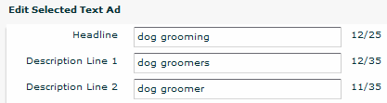

Ad Body Description

Google AdWords only gives you two lines of up to 35 characters each, so you need to make the most of this valuable piece of real estate.

Before you dive in and begin working on your own ad copy, sit down and take a look at the ad copy being used by others. Type something into Google’s search engine and then take a look at the top results in Sponsored Listings.

Obviously, the ads appearing toward the top are the ones that are most successful, so they are a great place to look for examples. Once you have read through several, you will start to get a good idea of how to most effectively use this limited area to your advantage.

Just as we did with your competitors’ headlines, let’s take a look at your competitors’ ad copy.

It is always a good idea to know what your competitors are up to. Once again, let’s type your keywords into Google’s search engine to study the top results in Sponsored Listings for your own niche.

Pay attention to the message your competitor is getting across. While we never want to copy anyone else’s work, we can model it.

What is the job of our ad copy? It can mention the benefits of your product or service. It can provide a reason for your readers to click and see what your web site has to offer. The more compelling the copy in the ad, the better your chance of success.

It may seem a bit daunting to try and fit everything you need to say into these two lines, each with a maximum character count of 35. It really is a small area to work with.

This is also part of what makes it so much fun. You must make each word count. As you play around with the ad copy, there is no room to be wordy.

What are the most important things for the reader to know about your site? Jot those words down. What action-based words can you think of that describe your product or service, or that directly relate to the advantages of clicking on your ad?

Take a look at your primary keywords for this ad campaign. Focus on those keywords and you will begin to see your ad copy take shape.

Make your ads as targeted as possible. It is often a good idea to create more than one ad campaign for the same product or service. This allows you to choose (or target) keywords for each campaign and then focus on those keywords in each campaign’s ads.

For example, Campaign A might focus on “holistic skin care,” while Campaign B might focus on “organic skin care.”

Both campaigns are all about skin care, but each drills down a little closer to the relevant keywords people are trying to find in search engines.

Rather than setting up one campaign and assigning many keywords to it, you should have better results if you set up separate campaigns paying attention to your targeted keywords.

As you write your ads, here are a few more tips.

It will be important to create an ad that tries to express to prospective clients your business’ top selling features.

Capitalize words that need to stand out and grab the customer’s attention. It is OK to ignore the rules you learned in English class at this point because you want the words to catch the eye of your customer.

Play around with your call to action. What is a call to action?

It is a phrase that tells the customer what they need to do next. People need to be shown the next step, so give it some thought before you include your call to action. What would you like for the customer to do next? Call now? Click here? Buy?

As you form the perfect ad, you will see that ad that brings about the best CTR will depend not only on the writing style, but also on the audience you target, the product itself, and the density of the search term within your ad.

Keep in mind that you will want to split test (discussed in another chapter) any alterations along the way, so that you will know exactly what works and what does not.

Make sure you use your keyword in the title. Most users scan the first line of your ad (also referred to as the headline) quickly.

If your keyword (which is the word they are looking for) pops out at them from the headline of your ad, they will be more likely to click on that ad.

The second line of your ad (right under the headline) should provide the user with a benefit.

Let them know why it would be to their advantage to click and visit your site. If your benefit is in harmony with their need, it increases the likelihood that they will click on your ad.

The next line is a perfect spot for your call to action. Include a sense of urgency to encourage them to click now, such as “Hurry! Offer Ends Today!” or “Act Now!”

Remember that the whole purpose of your ad is not to sell your product or service. Instead, the intention of the ad is to get the user to click.

Once the user is sent to your web site, it is your web site’s job to sell. Don’t fall into the all-too-common trap that so many AdWords advertisers are sucked into, which is turning a simple AdWords ad into a sales pitch.

Concentrate on why it would be an advantage for the user to click on your ad. What’s in it for them?

Relevancy is vital! You don’t want random clicks. You want clicks from the right people – potential customers. Do your best to make sure that the right people will be attracted to your ad.

They are looking for something specific, and it is what you have to offer. Take a good look at your ad, with the attitude of your customer, and ask yourself, “What would I want to find on a web site if I click this ad? How would it enhance my life?”

If ever you are studying your impressions vs. clicks vs. conversions (sales), and it seems like you aren’t getting enough conversions, the problem may lie in your ads providing incorrect expectations of what you web site actually offers.

Avoid using the word “buy” in your headlines. Potential customers might get the idea that visiting your site will cost them money and, therefore, avoid clicking on your ad.

Weed out unnecessary words such as:
- a
- an
- at
- etc.
- in
- the

Use action words when possible within your ad copy. To get you started, some examples of action words, and other words that have been proven to tempt clicks, include:

- Breakthrough
- Choose
- Compare
- Consultation
- Discover
- Download
- Enhanced
- Exclusive
- Exposed
- Free (but use this carefully, because you may get bombarded by clicks from people who want something for free, but have no desire to spend money on your product or service)
- Free Shipping
- Genuine
- Guaranteed
- Immediate
- Incredible
- Insider
- Instant
- Learn
- Limited
- Listen
- Magic
- New
- Phenomenal
- Power
- Results
- Revealed
- Revolutionary
- Secret
- Shocking
- Shop
- Special Offer
- Super
- Tactics
- Techniques
- Try
- Unbeatable
- Urgent
- Watch

Display URL
Your web site address will go here. It is best to use your real URL here (the home page of your site), rather than a URL that goes to a specific page within your site.

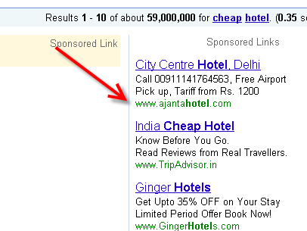

Even if your destination URL (discussed below) will send your visitor to a page other than the home page, it is best for the home page URL to show up here.

Destination URL
When someone clicks on your ad, where will they go? This is the URL that should be entered for your destination URL. You may not want to send the visitor to your home page. It may be best for them to go to a specific landing page or mini-site, and that’s fine.

Just make sure that you pay close attention to the differences between your display URL and destination URL, and enter the appropriate links when setting up your campaign.

Creating Winning Landing Pages

You have set up your campaign, written the AdWords ad, and now it is time for customers to start clicking.

Where will your customers go when they click? They will arrive on your landing page.

Once you have worked hard enough to get visitors to your landing page, it is vitally important for you to provide them with two things – relevant content and a clear call to action.

This is where your top-notch landing page will step into action.

First, we need to take a look at your landing page from the customer’s point of view.

Consider this:

Once your customer has clicked on your AdWords ad and arrived at your landing page, he or she will only spend a few seconds before clicking away – unless you have convinced the visitor there is a good reason to stay.

Some experts estimate that most computer users will make up their minds about staying or clicking away from a site within three seconds of arriving. With so much information available online, you must grab their attention and let them know that this is the site that will solve their problems. Otherwise, they will click away and you have likely lost them forever.

Give Them A Solution
By the time someone has parked themselves in front of the computer, typed a phrase into Google, and then takes a look at the results, they definitely have a problem that they are looking into.

They are looking to the Internet to find a way to solve that problem, ad you have the answer.

Your landing page is your opportunity to speak directly to their problem. Let this potential customer know that you have a way to ease their pain. Often, testimonials from previous clients will be just the ticket to proving that you really do have a resolution.

Call To Action
Customers want to be led to the next step. It obviously is true, when you stop and think about traditional advertising methods.

What do you often hear at the end of a television or radio commercial?

It is usually someone urging the listener to call, stop by, or visit a web site, which are all calls to action.

You have already gone to the trouble of interacting with the customer. You have convinced them to click on your ad and visit your site. Don’t take them this far only to lose them because you’re not sure what should happen next.

You should always, always, always have a call to action on your landing page.

What do you want them to do next? Buy? Click? Download a free report? Sign up for your Ezine? Order your product? Tell them!

At this point, the customer is entering your sales funnel. This is the point where they are, essentially, telling you, “I trust you. I give you permission to market to me forever, or until I tell you to stop by unsubscribing.”

Because the customer is now putting their trust in you, it is vital that you do not break that trust. How can you retain it?

By being very clear. Spell out exactly what you are offering the customer. Anything less could cause the customer to see warning signs and back out of the transaction.

Remember – A confused mind always says, “No!” This means that even the smallest problem could make your customer leave your landing page without buying.

So you need to go over your landing page carefully to make sure all instructions are clear and easy to understand.

If anything seems confusing, vague, or time-consuming, you may have lost your customer to the competition.

Generate Leads
One of the most important things you can do in order to build your business’ future is to capture leads.

If you work hard to get traffic to your landing page only to let them leave, you have wasted a lot of time, effort and money.
Setting up something as simple as an opt-in box to offer site visitors a free report can do wonders for your business.

Think of it as the difference between a one-night stand vs. dating. If your web site visitors come to your site and there is no opt-in box, it is like a one-night stand. They might enjoy the time they spend with you, but once they are gone you will likely never see them again.

However, if you offer your site visitors a free, downloadable report – whether it is something they can read or listen to – it is like dating. You will be able to establish a relationship with that customer, because they gave you their email address in order to get the free report.

Even if this person is not ready to buy at that very moment, you have already received two things that are very valuable – their email address and their trust.

The key to this free report is to make sure it provides quality content. Don’t send your customers an ebook that is identical to the ebooks offered on other web sites. Why would they want that if they can get it anywhere?

Create an original ebook or audio recording for this purpose. Make it short and straightforward.

Think of the topic in terms of “What’s in it for them?” (with the “them” being the customer of course).

What is it that you can share with them in this brief report or audio recording that will be a small taste of what they might receive if they went ahead and purchased your product or service? The idea is to tempt them.

Customers love checklists, cheat sheets, audio mp3 files, and mini reports. Create your own and watch your conversions go up.

Headline
Your landing page’s headline is meant to attract attention, draw the reader in, and encourage the reader to continue reading.
The same is true with the sub-headings throughout the page. Each one should urge the reader to continue reading the next section, and so on.

Most people skim web site copy, looking mainly at the headlines, followed by the bullet points. Make sure your headlines and bullet points are short, to the point, and avoid confusing the reader.

Layout
If at all possible, arrange your landing page so that the reader can see everything without scrolling. This is referred to as everything being “above the fold,” coined from the newspaper industry.

When a newspaper is folded in half and displayed in a newspaper vending machine or on a rack in a store, you only see what is above the fold.

I’m sure you have visited landing pages that required you to continue scrolling. In fact, I have seen some that, if printed, would require 35 to 40 sheets of paper. Usually, the longer the landing page, the higher the price point of the item.

It is best to keep the landing page short, concise, and easy to read.

Google made several changes to the AdWords program in July of 2006. Prior to that, the quality of a landing page was not really an issue.

However, a lot of people in online marketing and affiliate marketing awakened to discover that they keywords had been disabled over night, causing their ads to disappear.

These changes meant that Google had abruptly weighted the landing pages’ quality, making it stand next to the Quality Score of an advertisement.

Many advertisers felt that they had no choice other than to modify their bids, with some paying $5 or $10 to reactive their keywords.

These events of July 2006 were clumsy on Google’s part, according to many advertisers. A lot of them had to invest more money to keep their systems afloat, while others were unable to recover and gave up their online businesses.

How can you improve the quality of your landing page? By optimizing your landing page, paying special attention to:

- Providing relevant, original content that is aimed toward providing your visitors with answers to their questions or problems

- Honesty and transparency regarding the integrity of the products and services that you offer, how your site interacts with your customer’s computer and how you intend to use a visitor's personal information (privacy policies that ensure you will not sell or rent their email address, for example)

- Navigation – Always make the site as easy to maneuver as possible. Avoid unnecessary links that take visitors to other pages within your site. Under no circumstances should you provide a link for visitors to click and be taken away from your site. You worked hard to get them here, so you want to keep them here. They only things they should be able to click will be to purchase your products, get your free report, etc.

For more details about Google Adwords Landing Pages, visit:
http://AdWords.google.com/support/aw/bin/static.py?page=guidelines.cs&answer=46675&adtype=text

You may be asking yourself, “Why do I need a landing page? Shouldn’t I just send my AdWords customers to my web site’s home page?”
You could send potential customers to your main web site, but it will most likely confuse them. And, remember – A confused mind always says, “No!”

Think of it like this. If you were given the key to a brand new car and then told that it was sitting in the lot outside, waiting for you, but when you went outside you discovered a three-story parking garage filled with vehicles, would you be able to pick out the vehicle?

No, because there are too many to choose from and you just became that confused mind saying, “No!”

Your main web site (or your home page) likely tells the customer everything that you offer, how great your company is, it has an “About Us” page, contact information, some photos, and maybe even some video. It has spots to click to follow you on Facebook and Twitter.

But is that really what you want your visitor to see after you just spent money on the clicks to get them to your site?

The landing page gives you the chance to laser-target exactly what that customer needs to read or hear in order to move on to the next step. This is something that your home page does not do (and was never meant to do).
When you are planning your landing page, here are some things to consider in order to give your prospective customer the best possible experience.
The landing page should have one goal in mind (usually to get them to buy, but often to get them to opt-in with their email address, so that you can continue marketing to them, in exchange for a free report of some sort).
Your landing page should have well-written, meaningful content in order to convince the visitor that you really do know what they are going through with their problem, and you offer a valid, proven solution.
Well-organized landing pages will allow the visitor to quickly skim the page, rather than stopping to read each and every word, in-depth.

These days, most people are busy. They simply do not have time to read an extensive page. Use well-written headlines, sub-heads, and bullet points to make the landing page as easy to read as possible.
Your potential customer wants to see the benefits of your product of service, not the features. If you can express to the site visitor exactly how your product or service will help them, you have a better chance of success.

For example, don’t focus so much on the fact that your kit includes 10 CDs or DVDs. Instead, ask yourself what the customer will know, feel, accomplish, or be ready to do once they have studied these CDs or DVDs.

Concentrate on the skills and knowledge the customer will absorb from whatever you have to offer (the benefits). That is what they are looking for. That would be the solution to their problem that we have been discussing.
Something else to consider is your landing page’s URL or domain name.

If at all possible, your domain name should be the keyword or keyword phrase. Often, this is simply not possible since many domain names have already been purchased.

If you find yourself out of luck and unable to purchase your keywords as the domain name, then make sure your keywords are within the domain name that you choose.

Remember that Quality Score that we discussed earlier? Google AdWords does look at your domain name when assigning the Quality Score.

For quite a while, there has been much debate over whether or not to use hyphens in domain names or URLs. It is OK to use hyphens in your domain name if you need to separate individual words. This can actually be of benefit because it will help Google as it evaluates your domain name.

Human beings, however, tend to not even notice hyphens, which means many times they will type the URL into the browser box without including the hyphens, and end of in the wrong place. For this reason, you might consider purchasing both versions of your domain names – with the hyphens and without.

Another good reason to buy both versions of the domain names would be to prevent someone else from coming along and buying that version.

If you own both versions, you control both versions. You can avoid the possibility of the confusion that might ensue if a competitor decided to come along, buy the similar URL, and try to steer your traffic to his site.

Domain names are cheap. You could buy both versions for less than $20 per year. Once you have bought the extra domain name, redirect it so that, when someone enters it in a browser box, they will automatically be redirected to your other domain (the one with hyphens).

Take advantage of the fact that you can name your landing page file whatever you prefer. If you give it a name that includes the keywords that are appropriate for the landing page, it will be beneficial for your strategies.

By naming the landing page something that has to do with the fact that this is your AdWords landing page, it will allow Google to recognize the keywords in the destination URL. This is another chance to get your keyword in the AdWords ad. Each time this happens, Google will increase your Quality Score.

Another reason to use your keywords in the landing page name is to reassure your potential customers that they have, indeed, arrived at the appropriate web site. Anything you can do to help your customers rest assured that you are legitimate, the better.

Use your keywords in the meta tags for your landing page. Also, it is wise to make sure the description tag contains your keywords.

Present your keywords in the heading tag. Google loves to find the “h1” heading tags. Use them on the landing page, along with your keywords.

And, finally, use your keywords within the content of the landing page. There is no hard and fast rule regarding the number of times the keywords should appear or how often they should be repeated.

It is smart, however, to weave the keywords into the web site copy in a way that makes sense and flows like a conversation or an article. In other words, don’t insert your keywords surrounded by gibberish that makes absolutely no sense.

If this happens, it will be obvious to Google – and to your potential customers – that your site does not provide quality content and, therefore, can not solve the problem that caused the customer to seek your site in the first place.

Split Testing Your Campaigns

Split testing, also called A/B testing, has been around in the world of traditional advertising for a long time, and now online marketers have embraced this tool. It is easy to understand why, once you take a look at the powerful insight it can provide about your ad campaigns.

It can be as simple running two ads at once (or three at once, which is Google’s maximum), letting them compete against each other, to determine which one brought in better results and why.

Then, take this into consideration as you tweak your ads and make adjustments and improvements.

Once you make these modifications, you will be ready to run another split test. This time, take the ad that won last time and run it against an altered version of itself.

As you run a split test, your goal should be to make improvements to the ad in order to increase your CTR. High CTR is your key to success, and I am constantly amazed to see the number of AdWords users who do not understand this simple concept.

Your business will grow if you recognize the value of your CTR and continue to take steps to improve CTR.

What are some advantages of achieving a high CTR? Your AdWords campaign will receive more traffic, and you will pay less per click for that traffic.

Meanwhile, your competitors will pay more to accomplish the same ranking. If you are in a niche with fewer competitors, they will remain a small player receiving a small portion of clicks, since their ads will be forced lower down on the page. In a highly competitive niche, they might even be driven right out of the competition.

When you are ready to make changes to an ad, in preparation of a split test, only change one thing at a time.

Can you imagine how confusing it would be if you changed several things at once? Sure, you might have a clear winner when you compare the two (or three) ads, but if they are entirely different ads, you are defeating the purpose.

You want to run, basically, the same ad at the same time, with the exception of one word. Substitute that word for something else on the other ad(s). This way, as you look at the results, you’ll know which word that your potential customers preferred.

Leave that word alone the next time, and choose a different area of the ad to play with.

To allow the split test ads to receive equal exposure to potential customers, turn off the automatic optimization feature in your campaign-level options. Otherwise, Google’s default will automatically show the best performing ads more frequently, which would defeat the purpose of your split test.

Now that we understand the value of conducting a split test, how do we actually run one?

Go into the "Edit Campaign Settings" area and choose “Scheduling and Service.” After that, you will want to choose “Rotate: Show Ads More Evenly.”

Create one ad for this ad group. This will be the foundation of the ads that you will compare in the split test.

Will you be running a split test with two ads or three? If you will compare two ads, you will use the original ad, make a copy of it, and make a small change to the second ad. If you will use three ads in the split test, you will use the original ad, make two copies, and make small changes on #2 and #3.

The changes on ad #2 (and ad #3) that you might consider include:
- Changing one word in the headline
- Changing one word in the ad
- Including (or excluding) the price
- Tone of voice (formal or informal, for example)
- Capitalization on specific words in headline
- Capitalization on specific words in ad
- Symbols (@, using “2” instead of “to,” using “4” instead of “for,” for example)
- Punctuation (!, ?, …, quotation marks, a dash instead of a comma, for example)

Allow the ads within your split test to receive enough exposure. Whether you decide on 50 clicks or 500, one week or three, the goal is to let the testing give you a good idea about what really is (and is not) working.

If you look at your results too early in the game, you won’t have a true picture of the outcome, which will prevent you from making the right decisions as far as which version of the ad brought in the best results.

Now that you have conducted the split test for a period of time (or certain number of clicks), how do you know which was the most responsive ad?

The one with the highest click through ratio, or if you are tracking conversions by metrics such as cost per conversion.

Your next step will be to prepare a new ad to go up against the previous winner.

Remember to reset the statistics for the winning ad before the next split test begins. It is easy to trigger this in your account.

Open the ad that won your split test, make a tiny change ( as removing a character from the ad) and then restore the change.

AdWords will sense that the ad has been revised, and it will then reset the CTR to zero. You will now be ready to start the next split test.

If you make split testing a regular activity, you will be able to continuously improve the of your ad campaigns and generate higher returns for your ad budget.

In the beginning stages of an ad campaign, you will likely perform the most split testing in the first few weeks and then level off with ads that have proven themselves to be winners.

However, don’t sit back on your laurels with the idea that you no longer need to mess around with split testing.

Playing around with slit testing once in a while can be a fabulous way to keep yourself – and your ad campaigns – on their toes. And, if anything starts to slip or you simply desire better results, sharpen your pencil once again and start playing around with split testing.

Tracking Cost of Sales

In any type of business, you want to know how much it costs to make each sale. This helps you determine how profitable your business really is. Your AdWords business is no exception. Let’s take a look at how and why you should track cost of sales.

In the early days of Internet marketing, a lot of people who had been in the direct marketing industry jumped onboard and brought with them many of their theories and ideas, including the creation and utilization of classified ads in newspapers and magazines, and then following up with the leads who responded to these methods.

In direct marketing, generating these leads was more expensive than our online methods, since it simply costs more to purchase advertising space in publications, and to have advertising pieces designed and mailed.

These early methods also took a lot more time, because ads in publications must be purchased far in advance of the dates they will be in the hands of readers, and it takes time to go through the process of mailing various postcards and letters to your leads and then waiting to see which mailers receive the best response.

We have taken the basic ideas from the world of direct marketing and adapted them so that our online businesses can be studied, as well.

These ideas include:

ROI = Return On Investment. This is how many dollars you earn per dollar spent on PPC. A PPC Advertising ROI Calculator is available online at: http://www.bplans.com/business_calculators/ppc_roi.cfm.
The calculator asks you to enter the number of clicks purchased, cost per click and average dollar amount each buyer purchases.
Conversion = A visitor to your site who chose to opt-in to your offer and become a paying customer or lead.
CR = Conversion Rate. This is the total conversions divided by number of clicks, which yields the percentage of users who opt-in to your offer after viewing your landing page.
CPA = Cost Per Acquisition. This is the total cost divided by number of conversions, which yields the average cost per conversion.

Conclusion

Pay Per Click marketing is a fascinating area, constantly growing and evolving.

When compared to other forms of online marketing, PPC offers numerous rewards for your business building strategies.

PPC campaigns are relatively easy to set up, taking just a few minutes once you get the hang of it. They are also relatively inexpensive to get started, since you can begin playing around with $50.00 or less.

As the number of people using the Internet continues to grow each week, thousands of users search the web each day, looking for specific information, products and services. You have the opportunity to be the one to satisfy their needs, and reap the financial benefits.

With your ad appearing on the first page of Google’s search results, you will dramatically increase the chances of guiding hundreds of targeted leads to your web site each day. One of the fabulous things about PPC marketing is that your PPC advertisement could begin showing up within 30 minutes from the time you create your campaign.
Nothing beats the speed and potential profitability of having a fine tuned, tweaked and targeted advertisements reaching out to your target audience and driving them onto your website 24 hours a day, effortlessly. Nothing.

By targeting the right type of customers with your PPC marketing ad campaign, you will present your ads to individuals who are actually looking for your products and services. They want to find you online, so this is your chance to make yourself known.

Another great thing about Google PPC AdWords is that the system’s dashboard is easy to control and it lets you monitor your ad campaigns.

We hope that this guide has inspired you to schedule some time in front of your computer, ready to follow the steps necessary in order to set up your own ad campaigns.

Good luck to you as you pursue your endeavours and begin to build your online empire!
PPC Marketing Millions
YOUR DOMAIN HERE

